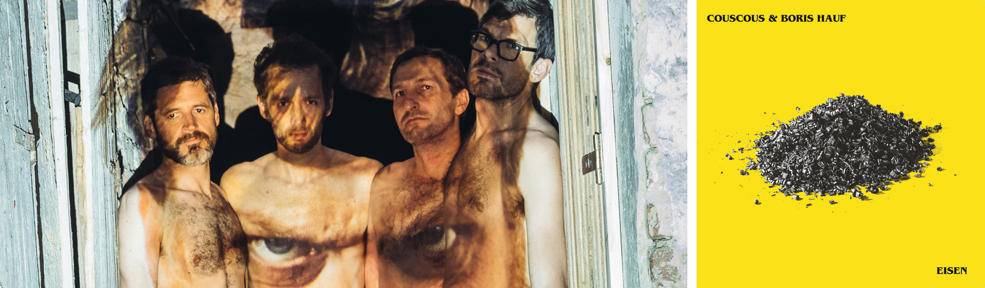
Couscous & Boris Hauf „Eisen“

The audiovisual group Couscous has found a soul mate in noise, chaos and harmony in the internationally active improv musician Boris Hauf. “Eisen” is the continuation of their collaboration, starting with the 2013 release “Trans”. The bluntness and creativity of how Couscous intermingle musical aspects of different cultures is enriched by the alliance with this powerful horn player. Hauf’s baritone saxophone sound combined with his detailed and blissfully fractured approach to melody mixes surprisingly well with the off-balanced and angular sound Couscous has built.

Joyfully and almost indiscernibly Couscous and Hauf experiment with genres, exotic and self-made musical instruments. A turkish Saz uninhibitedly takes center stage, while industrial sound textures get counterbalanced with a fierce percussion and a slightly passive-aggressive guitar. A sea of trombones, saxophones and clarinets, piano clusters and a stubborn bass form a billowing and saturated foundation for this musical bazar. The quintet actively blurs boundaries, alternates arrangements with collective improvisation, and lightheartedly throws musical curveballs to unhinge the narrowly defined euro-centric approach to contemporary music.

Past cooperations with Damo Suzuki, Thollem McDonas, Ulrike Hager with Warszawski Teatr Tańca, Martin Zeplichal, Sebastian Six, Marina Marsilio etc.

Martin Max Offenhuber (Kreisky): baglama-saz, bass synthesizer, ektar, ghosttubes.
Thomas Binder-Reisinger (David Lipp & die Liebe): guitar, guzli. Ralph Wakolbinger (Die Buben im Pelz, Aber das Leben lebt, The Maybe Men): drums / percussion. Andreas Ledl (Hard-Chor): bassguitar, clarinet. Boris Hauf (Efzeg, Peeled Eye, Next Delusion, Boris Hauf Sextett u.v.m.) baritone sax, piano.

Martin Max Offenhuber „Couscous“, pumpkin records, 2006
Couscous, „Trans“, pumpkin records, 2013

couscous.klingt.org hauf.klingt.org facebook.com/Couscousband
noiseappeal.com

